**Project Planning Phase**

|  |  |
| --- | --- |
| Date | 09 November 2022 |
| Team ID | PNT2022TMID35083 |
| Project Name | IoT based safety gadget for child safety monitoring and notification |
| Maximum Marks | 8 Marks |

**Product Backlog, Sprint Schedule, and Estimation (4 Marks)**

Use the below template to create product backlog and sprint schedule

| **Sprint** | **Functional Requirement (Epic)** | **User Story Number** | **User Story / Task** | **Story Points** | **Priority** | **Team Members** |
| --- | --- | --- | --- | --- | --- | --- |
| Sprint-1 |  | US-1 | Create the IBM Cloud services which are being used in this project. | 6 | High | Vimal Nishanthan.T  Srinath. A  S.Surya Prakash  Sujith .S  Vishnu Prasath.S |
| Sprint-1 |  | US-2 | Configure the IBM Cloud services which are being used in completing this project. | 4 | Medium | Jeshrin Reubsiga.T  Devika.I  Gayathri.M  Kalaiarasi.P |
| Sprint-2 |  | US-3 | IBM Watson IoT platform acts as the mediator to connect the web application to IoT devices, so create the IBM Watson IoT platform. | 5 | Medium | Jeshrin Reubsiga.T  Devika.I  Gayathri.M  Kalaiarasi.P |
| Sprint-2 |  | US-4 | In order to connect the IoT device to the IBM cloud, create a device in the IBM Watson IoT platform and get the device credentials. | 5 | High | Jeshrin Reubsiga.T  Devika.I  Gayathri.M  Kalaiarasi.P |
| Sprint-3 |  | US-1 | Configure the connection security and create API keys that are used in the Node-RED service for accessing the IBM IoT Platform. | 10 | High | Jeshrin Reubsiga.T  Devika.I  Gayathri.M  Kalaiarasi.P |
| Sprint-3 |  | US-2 | Create a Node-RED service. | 10 | High | Jeshrin Reubsiga.T  Devika.I  Gayathri.M  Kalaiarasi.P |
| Sprint-3 |  | US-1 | Develop a python script to publish random sensor data such as temperature, moisture, soil and humidity to the IBM IoT platform | 7 | High | Jeshrin Reubsiga.T  Devika.I  Gayathri.M  Kalaiarasi.P |
| Sprint-3 |  | US-2 | After developing python code, commands are received just print the statements which represent the control of the devices. | 5 | Medium | Jeshrin Reubsiga.T  Devika.I  Gayathri.M  Kalaiarasi.P |
| Sprint-4 |  | US-3 | Publish Data to The IBM Cloud | 8 | High | Jeshrin Reubsiga.T  Devika.I  Gayathri.M  Kalaiarasi.P |
| Sprint-4 |  | US-1 | Create Web UI in Node- Red | 10 | High | Jeshrin Reubsiga.T  Devika.I  Gayathri.M  Kalaiarasi.P |
| Sprint-4 |  | US-2 | Configure the Node-RED flow to receive data from the IBM IoT platform and also use Cloudant DB nodes to store the received sensor data in the cloudant DB | 10 | High | Jeshrin Reubsiga.T  Devika.I  Gayathri.M  Kalaiarasi.P |

**Project Tracker, Velocity & Burndown Chart: (4 Marks)**

| **Sprint** | **Total Story Points** | **Duration** | **Sprint Start Date** | **Sprint End Date (Planned)** | **Story Points Completed (as on Planned End Date)** | **Sprint Release Date (Actual)** |
| --- | --- | --- | --- | --- | --- | --- |
| Sprint-1 | 20 | 3 Days | 31 Oct 2022 | 02 Nov 2022 | 20 | 02 Nov 2022 |
| Sprint-2 | 20 | 3 Days | 02 Nov 2022 | 05 Nov 2022 | 20 | 05 Nov 2022 |
| Sprint-3 | 20 | 3 Days | 05 Nov 2022 | 08 Nov 2022 | 20 | 08 Nov 2022 |
| Sprint-4 | 20 | 3 Days | 11 Nov 2022 | 14 Nov 2022 | 20 | 14 Nov 2022 |

**Velocity:**

Imagine we have a 10-day sprint duration, and the velocity of the team is 20 (points per sprint). Let’s calculate the team’s average velocity (AV) per iteration unit (story points per day)

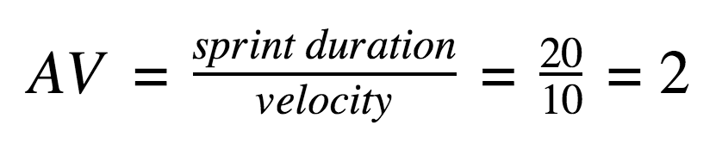

**Burndown Chart:**

A burndown chart is a graphical representation of work left to do versus time. It is often used in agile software development methodologies such as Scrum. However, burndown charts can be applied to any project containing measurable progress overtime.

